**NANDHA ENGINEERING COLLEGE**

**(Autonomous Institution)**

Erode-638 052



**TABLEAU-TWO CREDIT COURSE**

**IV – Semester**

**B.Tech - Artificial Intelligence and Data Science**

**NAME : S.GUHAN**

**BRANCH : B.TECH AI & DS**

**YEAR : II**

Introduction:

**TABLEAU DEFINITION AND USES**

**Tableau is a powerful data visualization and business intelligence platform that enables users to create interactive and shareable dashboards. It allows for the exploration, analysis, and presentation of data through intuitive visualizations such as charts, graphs, and maps. Tableau connects to various data sources, including spreadsheets, databases, and cloud services, to transform raw data into actionable insights.**

**Uses :**

**• Data Visualization : Create dynamic and visually appealing representations of complex datasets.**

**• Data Analysis : Perform exploratory data analysis to uncover trends, patterns, and outlier**

# Overview of this project:

Summary:

Amazing Interactive Tableau Dashboard – Amazon Sales in India

This Tableau dashboard provides an interactive visual analysis of Amazon’s sales data in India. It focuses on multiple key aspects:

Overall Sales Performance:  
Visuals like bar charts, KPI cards, and time-series graphs show the total revenue, profit, and order counts over time.

Category and Sub-Category Analysis:  
 Breakdowns of sales and profits by product categories (like Electronics, Fashion, Home Essentials, etc.) help spot which segments perform best.

Regional Sales Insights:  
 A map of India highlights state-wise or city-wise sales performance, identifying top-performing and low-performing regions.

Customer Behavior:  
 Metrics like customer orders, average order value, and repeat purchase rates are shown to understand buying patterns.

Profitability Trends:  
 The dashboard tracks profit margins, showing where Amazon gains the most versus where margins are thin.

Filters and Interactivity:  
 Users can interact by selecting date ranges, product categories, or regions to dynamically update the visualizations.

# Key Features:

1. Dynamic drill-downs (e.g., from category → sub-category → product level)
2. Custom tooltips showing extra details on hover
3. Trend lines and forecasts for predictive analysis
4. Responsive layout for desktop and mobile view

Top 10 states by quality and category

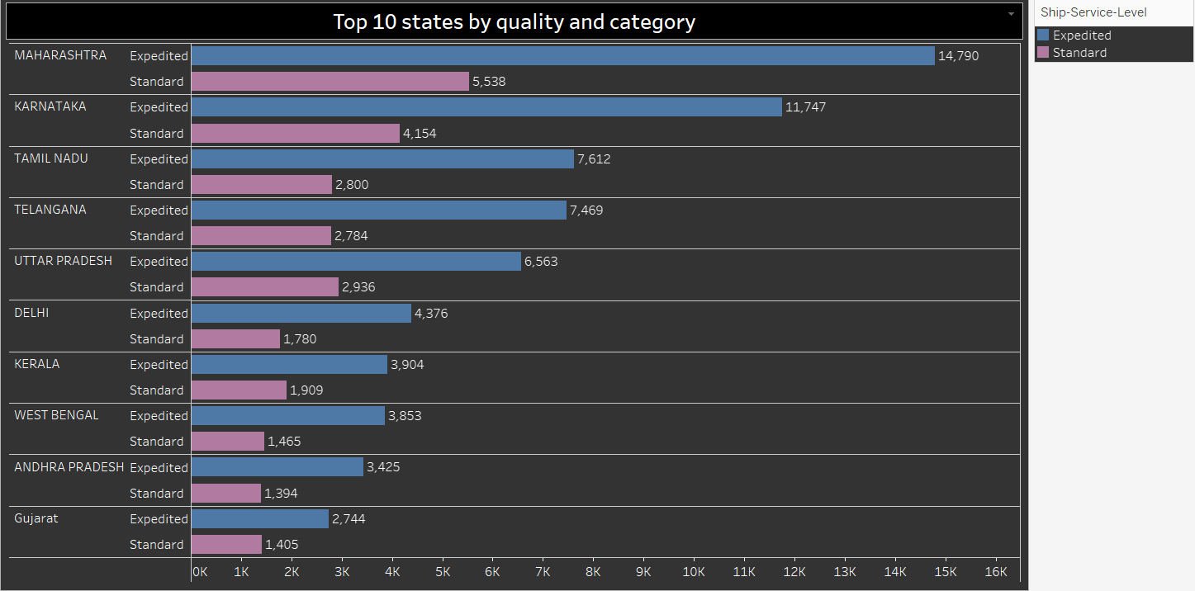

Definition **:**

Chart Type:  
Horizontal Grouped Bar Chart.

Purpose:  
To display the **top 10 states** based on **sales quantity**, divided by **shipping service level** (Expedited vs Standard).

#### Data Representation:

Each state has two bars:

**Blue bar** = Expedited shipping quantity.

**Pink bar** = Standard shipping quantity.

The length of the bars shows the **volume of orders**.

Key Insight:

How much shipping happens through expedited vs standard services in each state.

Which states have the highest overall quantities.User Interaction:  
(If enabled) Users might filter or sort based on quantity, shipping method, or category.

### **Business Use**: Helps Amazon or sellers understand customer preference for faster shipping and plan logistics or promotions accordingly.

**Visual Impact**:  
 Quickly identifies states with strong demand for expedited deliveries, hinting at customer urgency or premium service interest.

# Chart :2

## Quality by status and category

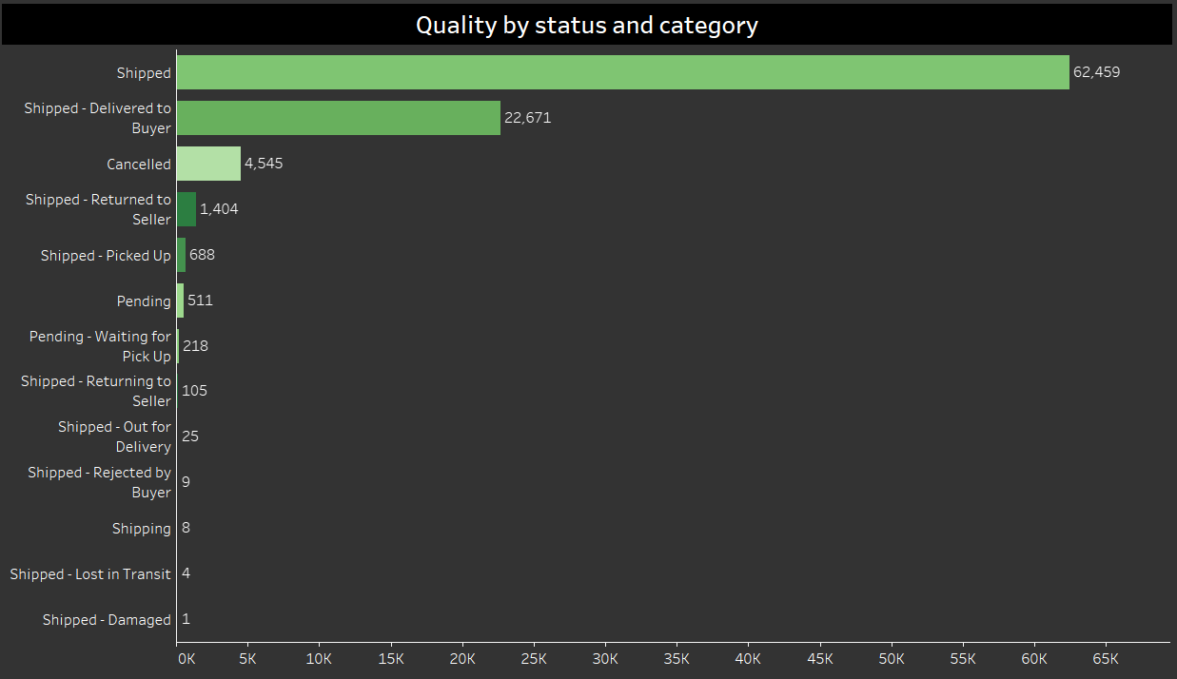

**Definition :**

* **Chart Type**:  
   Horizontal Bar Chart.
* **Title**:  
   **Quality by status and category**.
* **Purpose**:  
   To display the **distribution of shipment statuses** across different categories.
* **Data Representation**:

Each bar represents a **shipment status** (like Shipped, Delivered, Cancelled, etc.).

The **length of the bar** shows the **volume of orders** in that status.

The **number of orders** is labeled on each bar.

**Key Observations**:

* **"Shipped"** status dominates with **62,459 orders**.
* **"Shipped - Delivered to Buyer"** is the second most common with **22,671 orders**.
* **"Cancelled"** orders are relatively high at **4,545**.
* Other statuses like "Returned to Seller," "Picked Up," "Pending," etc., have much smaller volumes.
* Very minimal counts for issues like **damaged**, **lost in transit**, or **rejected by buyer**.

# Chart :3

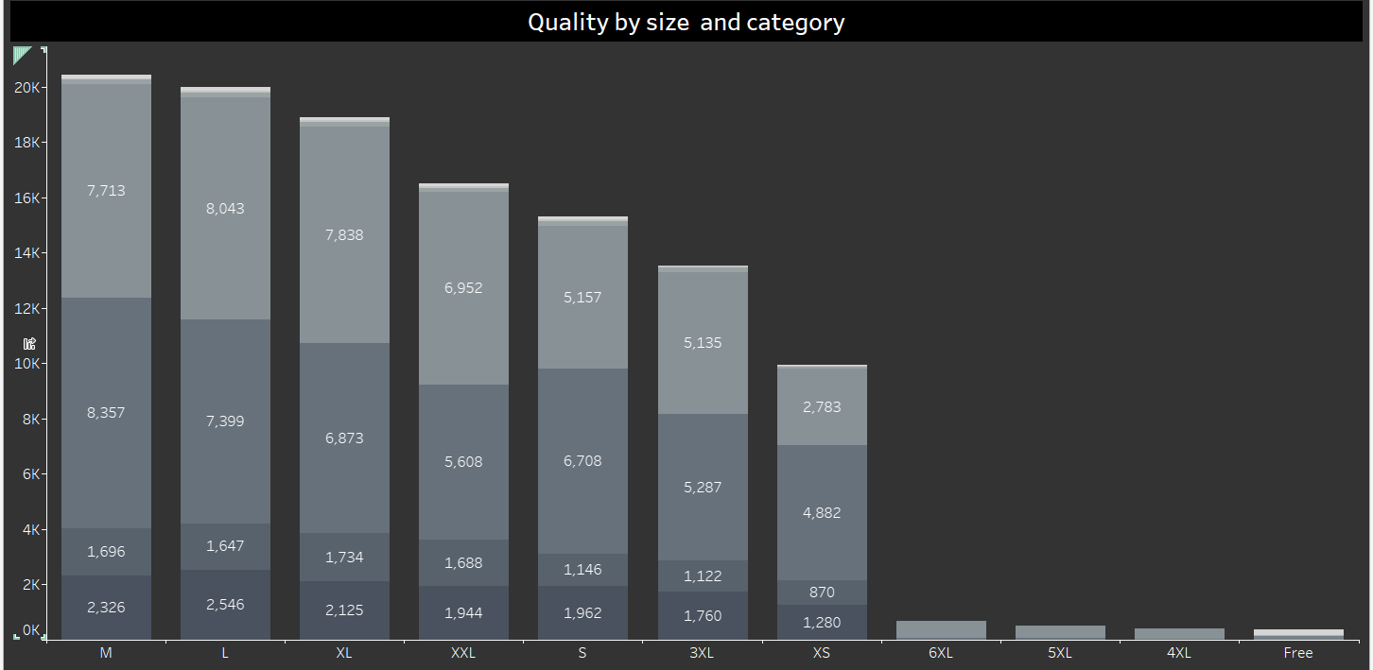

Definition (Point by Point):

Chart Type:  
 Stacked Vertical Bar Chart.

Title:  
 Quality by size and category.

Purpose:  
 To visualize and compare shipment volumes across different product sizes, broken down by shipment category/status.

Data Representation:

The X-axis shows different product sizes (XS, S, M, L, XL, XXL, 3XL, 4XL, 5XL, 6XL, and Free Size).

The Y-axis represents the quantity (Qty) of shipments.

Each stacked bar represents the total quantity for that size, with different shades indicating different categories (like shipped, delivered, pending, cancelled, etc.).

Key Observations:

Medium (M) and Large (L) sizes have the highest shipment quantities, followed closely by XL.

Smaller sizes (like XS) and very large sizes (like 5XL, 6XL, 4XL) have much lower shipment volumes.

Free size shipments are minimal compared to standard sizes.

# Chart:4

## Quality by week and category

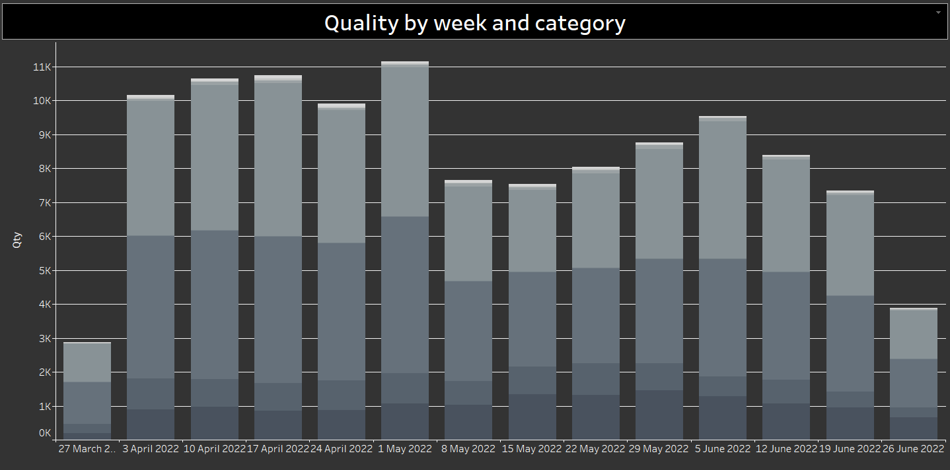

### Definition:

Chart Name:

Quality by Week and Category

Purpose:

To visualize the total quality output over time, segmented by categories.

To track weekly performance and identify any fluctuations or trends.

To analyze which categories contribute most to the total quantity each week.

Structure:

X-Axis: Week ending dates (from 27 March 2022 to 26 June 2022).

Y-Axis: Quantity (Qty) — total number measured, in thousands (K).

Bars: Stacked by different categories (each color shade represents a different category).

Insights Provided:

Detect volume peaks (e.g., weeks of 1 May and 5 June show highest quantities).

Identify decline trends (e.g., end of June shows a drop).

Compare category contributions week over week.

Usage (Amazon context):

Evaluate quality performance across fulfillment centers, product categories, or quality processes.

Spot operational issues or success periods based on weekly trends.

Support data-driven decisions on where to focus improvement efforts.

# Chart:5

## Amount by week and category

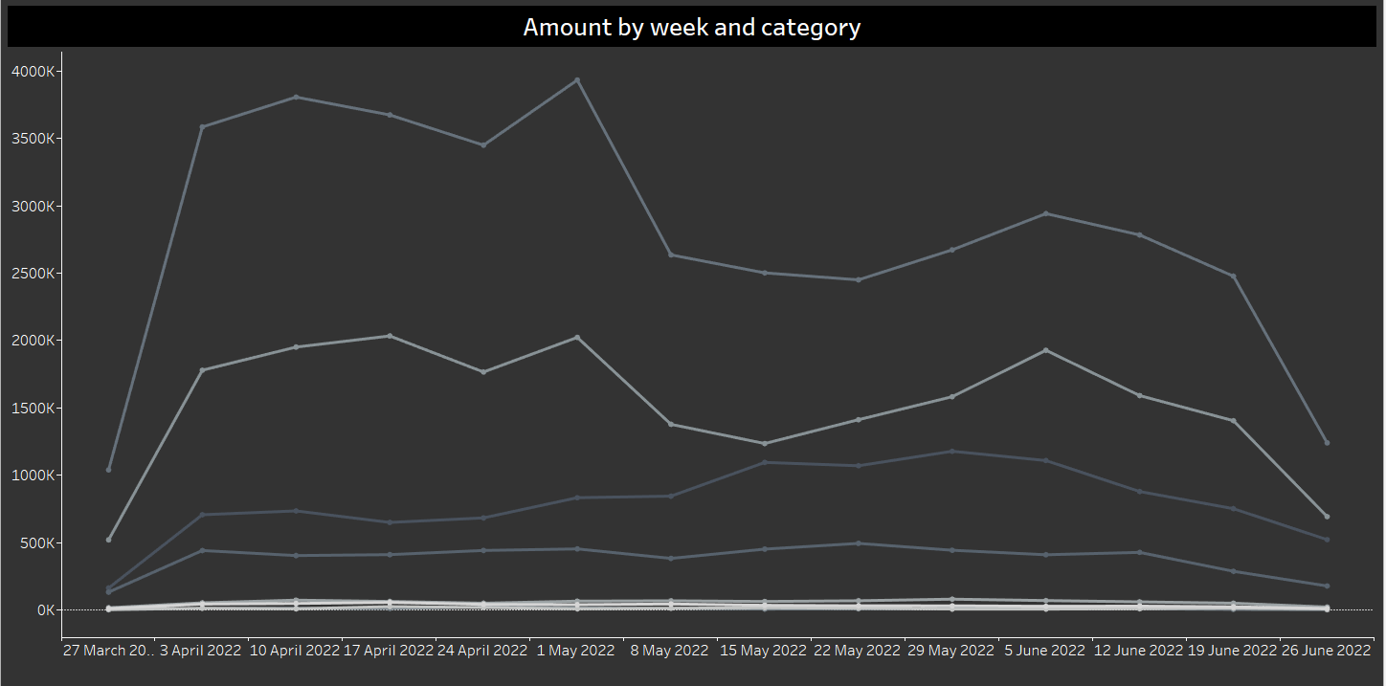

#### 

DEFINITION:

Chart Name:

Amount by Week and Category

Purpose:

To show how the amount (likely sales, transactions, or outputs) changes week over week for each category.

To track volume trends over time across multiple categories.

To identify peak and low performance periods for different categories.

Structure:

X-Axis: Week ending dates (from 27 March 2022 to 26 June 2022).

Y-Axis: Amount (K) — numerical value in thousands.

Lines: Each line represents a different category; lines show the trend for that category week by week.

# Chart:6

## Map quantity by state

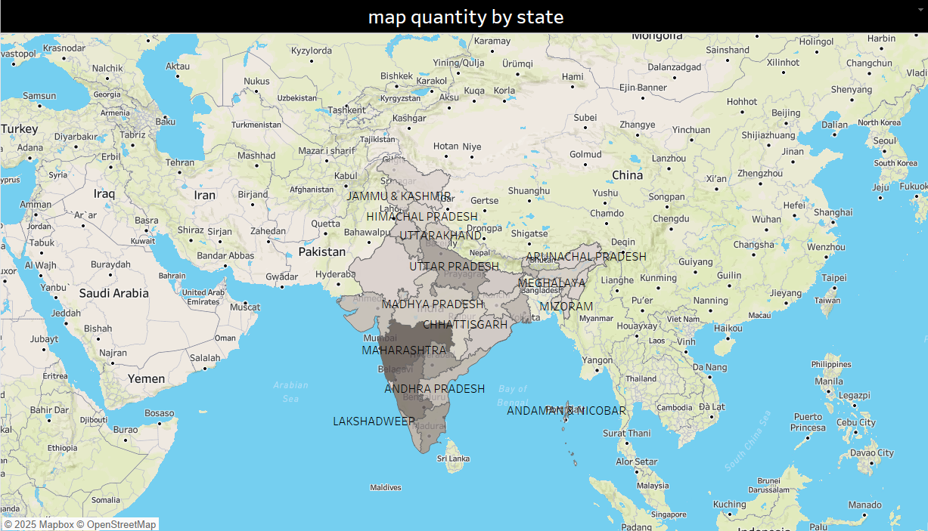

DEFINITION:

Chart Name:

Map Quantity by State

Purpose:

To show the distribution of quantity (sales, orders, or outputs) geographically across Indian states.

To visually identify which states have higher or lower quantities at a glance.

To support regional analysis and targeted decision-making (marketing, supply chain, resource allocation).

Structure:

Base Map: A geographic map (focused on India, using Mapbox and OpenStreetMap).

Shading/Color Intensity: States are shaded darker or lighter depending on their quantity — darker shades indicate higher quantities.

Labels: Each state name is overlaid on the map for easy identification.

Insights Provided:

States like Maharashtra, Andhra Pradesh, and Tamil Nadu appear darker, suggesting higher quantities.

Northern and Northeastern states are generally lighter, indicating lower quantities.

Useful to see where demand or activity is concentrated geographically.

Usage (Amazon context):

Identify top-performing states for product delivery or sales.

Plan logistics, inventory, and marketing strategies based on regional performance.

Detect growth opportunities in underperforming regions.

# CHART:7

## 

## Quality by courier status and category

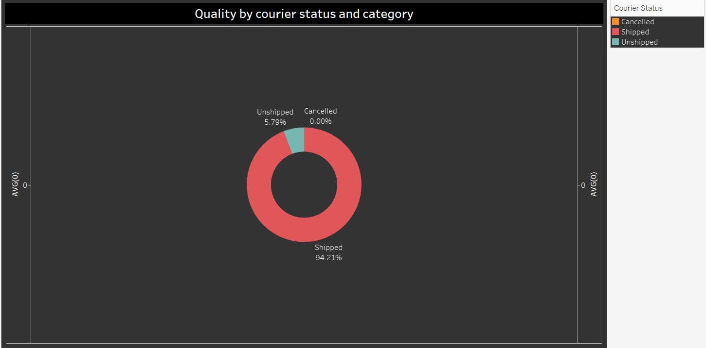

# DEFINITION:

Chart Name:

Quality by Courier Status and Category

Purpose:

To show the distribution of shipment status (Cancelled, Shipped, Unshipped) across all orders or items.

Helps analyze operational performance in terms of delivery fulfillment.

Structure:

Type: Donut (ring) chart.

Sections:

Shipped (red) – majority portion (94.21%).

Unshipped (light teal) – small portion (5.79%).

Cancelled (orange) – very negligible (0.00%).

Legend: Displayed on the right, clearly mapping colors to courier statuses.

Labels: Percentage values are shown inside/outside the donut slices.

Insights Provided:

Most of the orders are successfully shipped (over 94%).

Unshipped orders form a small proportion but are still noticeable (~6%).

Cancellations are almost non-existent, which reflects good service quality.

**Usage (Amazon or e-commerce context):**

Evaluate shipping efficiency and customer service levels.

Spot issues with order processing or logistics (if Unshipped % were higher).

Monitor and maintain very low cancellation rates.

# DASHBOARD:

# Amazon sales and data analysis

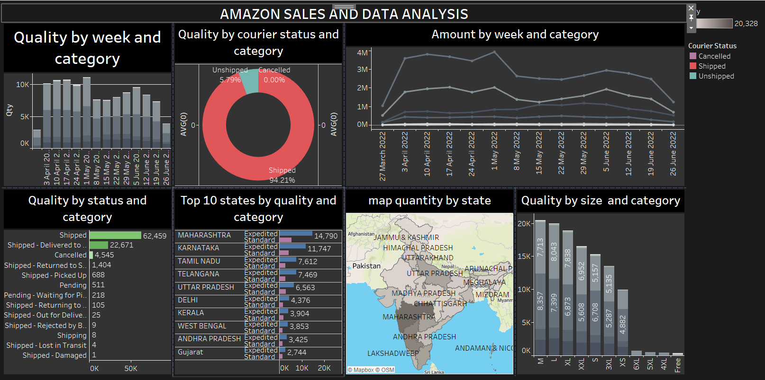

# CONCLUSION:

Amazon’s order fulfillment operations are highly effective, with excellent shipping quality, strong performance across major Indian states, and good product size diversity. Continued focus on minimizing unshipped and delayed orders will further enhance customer satisfaction.